Comp2147- Lab9
Name: Garv, Student ID: 101566625
Conceptual Model:
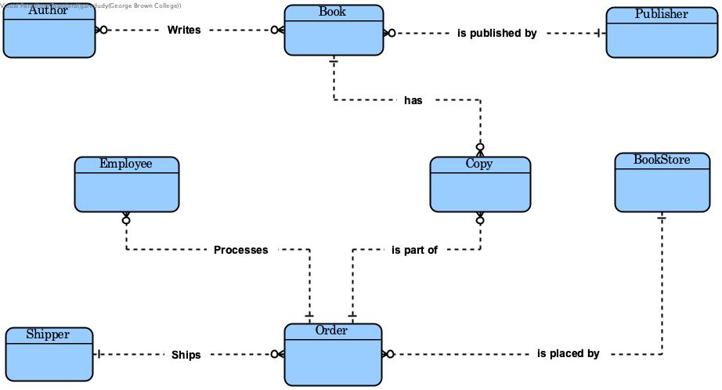
Physical Model:
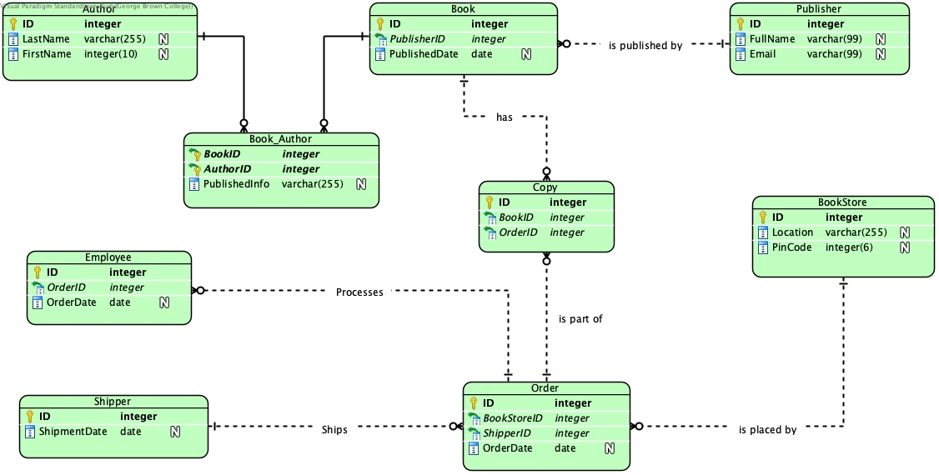
Class Diagram:
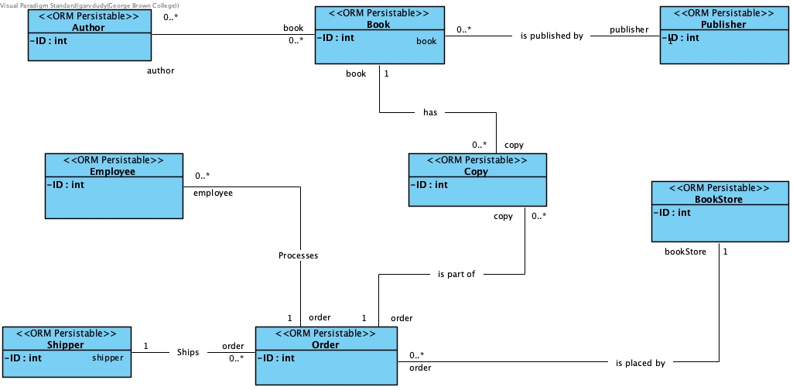

Thank You Professor……

